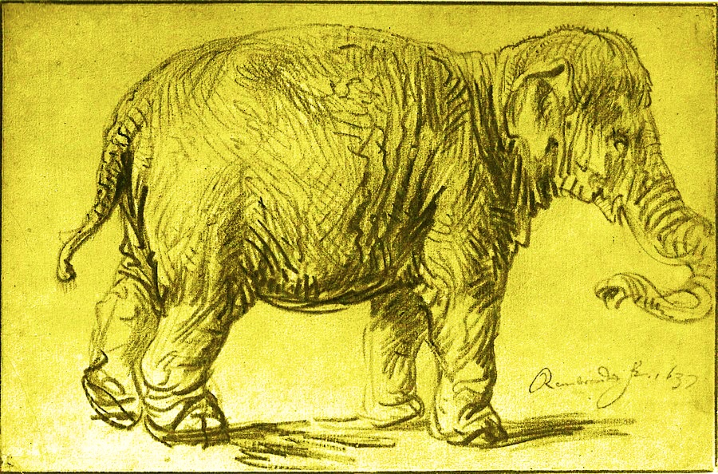

Rembrandt, *An Elephant*, 1637